C H A P T E R 11

Working with OLE Embedded and OLE Linked Objects

This chapter outlines guidelines for the interface for OLE embedded and OLE linked objects. While the primary focus assumes implementation using Microsoft OLE technology, you can apply many of these guidelines to the interaction between containers and their components.

The Interaction Model
As data becomes the major focus of interface design, information content occupies the user's attention rather than the application managing the information. In such a design, data is not limited to its native creation and editing environment (the application); information can be transferred to other types of containers (for example, documents) while maintaining its viewing and editing capability in its new container.

Compound documents are a common example and illustration of the interaction between containers and their components. This does not imply they are the only expression of this kind of relationship. Furthermore, the use of the term document does not suggest that this design is only relevant to word-processing documents. Spreadsheets, charts, drawings, and forms are also documents.

Figure 11.1 is an example of an OLE compound document. The document includes word-processing text, tabular data from a spreadsheet, a sound recording, and pictures created in other applications.

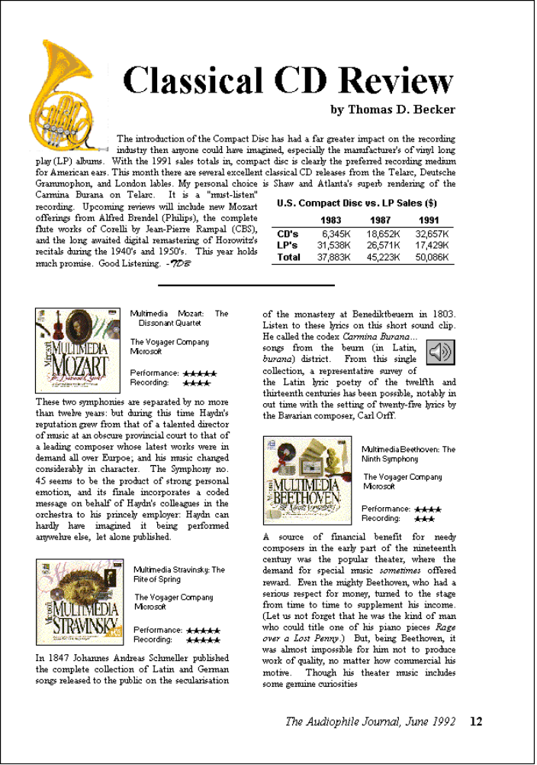

Figure 11.1 A Compound Document with Linked and Embedded Objects.
How was this music review actually created? First, a user created a new document and typed in the text. Then the user moved, copied, or linked content from other documents. OLE embedded objects are data objects that when moved or copied retain their native, full-featured editing and operating capabilities in their new container..

Information can also be linked. A link is a connection between two objects. Links can be presented in various ways in the interface. For example, a data link propagates a value between two objects, such as between two cells in a worksheet or a series of data in a table and a chart. An OLE linked object represents or provides access to another object that resides at another location in the same container or a different, separate container. A shortcut icon is any kind of a link, displayed as an icon, that provides navigational access to another object located elsewhere.
Generally, containers support any level of nested OLE embedded and linked objects. For example, a user can embed a chart in a worksheet which, in turn, can be embedded within a word-processing document. The model for interaction is consistent at each level of nesting.

Creating OLE Embedded and Linked Objects
OLE embedded and linked objects are the result of transferring existing objects or creating new objects of a particular type.

Transferring Objects
Transferring objects into a document follows basic command and direct manipulation interaction methods. The following sections provide additional guidelines for these commands when you use them to create embedded or linked objects.

For more information about command and direct manipulation transfer methods, see Chapter 5, "General Interaction Techniques."

The Paste Command
As a general rule, the Paste command should result in the most complete representation of a transferred object; that is, the object is embedded. However, containers that directly handle the transferred object can optionally accept it as native data instead of embedding it as a separate object, or as a partial or transformed form of the object if that is more appropriate for the destination container.

If the user pastes and embeds an object that is a file, then include the object's filename as part of the Paste command. If the object is only a portion of a file, use the short type name; for example, Paste Worksheet or Paste Recording, as shown in Figure 11.2. A short type name can be derived from information stored in the system registry. A Paste command with no name implies that the data will be pasted as native information.

For more information about type names, see Chapter 10, "Integrating with the System."

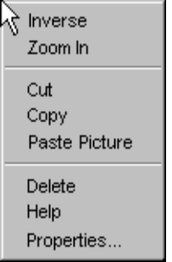

Figure 11.2 The Paste Command with a Short Type Name.

The Paste Special Command
The Paste Special command can be used to provide a user with explicit control over pasting in the data as native information, an OLE embedded object, or an OLE linked object.

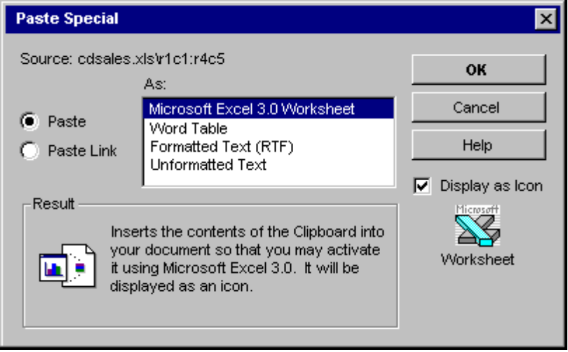

Figure 11.3 The Paste Special Dialog Box.
The Paste Special dialog box includes a list box with the possible formats that the data can assume in the destination document.

Note
The Microsoft Windows Software Development Kit includes the Paste Special dialog box and other OLE related dialog boxes that are described in this chapter.

In the formats listed, include the object's full type name first, followed by other appropriate native data forms. When a linked object has been cut or copied, precede its object type by the word "Linked" in the format list. For example, if the user copies a linked Microsoft Excel 5.0 worksheet, Paste Special should show "Linked Microsoft Excel 5.0 Worksheet" in the format options because it inserts an exact duplicate of the original linked worksheet. Native data formats can be expressed using the same terms as the destination application uses in its own menus and begin with the destination's (application) name. The initially selected format in the list corresponds to the format that the Paste command would result. For example, if the Paste command displays Paste <Object Filename> or Paste <Short Type Name>, because the data being pasted is a file or portion of a file, then this is the format that is initially selected in the Paste Special list box..

To support creation of a linked object, the Paste Special dialog box includes a Paste Link option.

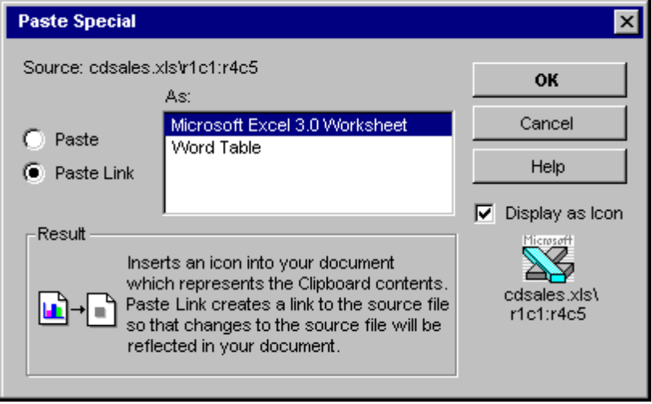

Figure 11.4 Paste Special Dialog Box with Options Set for a Linked Object.
A Display as Icon check box allows the user to choose displaying the embedded or linked object as an icon.

At the bottom of the dialog box is a section that includes descriptive text and pictures to describe the result of the operation. Table 11.1 lists the descriptive text for use in the Paste Special dialog box.

Table 11.1 Descriptive Text for Paste Special
Function | Descriptive text
Paste as an embedded object. | "Inserts the contents of the Clipboard into your document so you that you may activate it using <brandname application>."
Paste as an embedded object so that it appears as an icon. | "Inserts the contents of the Clipboard into your document so you that you may activate it using <brandname application>. It will be displayed as an icon."
Paste as native data. | "Inserts the contents of the Clipboard into your document as <native type name, and optionally an additional help sentence>."
Paste as a linked object. | "Inserts a picture of the contents of the Clipboard into your document. Paste Link creates a link to the source file so that changes to the source file will be reflected in your document."
Paste as a linked object so that it appears as a Shortcut icon. | "Inserts a Shortcut icon into your document which represents the contents of the Clipboard. A link is created to the source file so that changes to the source file will be reflected in your document."
Paste as linked native data. | "Inserts the contents of the Clipboard into your document as <native type name>. A link is created to the source file so that changes to the source file will be reflected in your document."

The Paste Link, Paste Shortcut, and Create Shortcut Commands
If linking is common, you can optionally include a command that optimizes this process. Use Paste Link to support creating a linked object or linked native data. When using the command to create a linked object, include the name of the object preceded by the word "to"; for example, "Paste Link to Latest Sales." Omitting the name implies that the operation will result in linked native data.

Use Paste Shortcut to support creating a linked object that appears as an a shortcut; that is, as an icon. You can also include a Create Shortcut command that creates a shortcut icon in the container. These latter commands generally only apply to containers where icons are a commonly used.

Direct Manipulation
You can also support direct manipulation interaction techniques, such as drag-and-drop, for creating embedded or linked objects. When the user drags a selection into a container, the container may interpret the operation using information supplied by the source, such as the selection's type and format, and the destination's own context, such as the container's type and default transfer operation. For example, dragging a spreadsheet cell selection into a word processing document would likely result in an OLE embedded table object. However, dragging the same cell selection within the spreadsheet would result in simply transferring the data as native data. Similarly, the container also determines whether the dragged object creates a linked object. For nondefault drag-and-drop, the destination determine the appropriate commands to present on the resulting pop-up menu and executes the operation corresponding to the user's choice on that menu. For links, the choices can include, Link Here, Link <Short Type Name> Here and Create Shortcut Here.

For more information on using direct manipulation for moving, copying, and linking objects, see Chapter 5, "General Interaction Techniques."

The default appearance of the transferred object also depends on the destination (dropped on) container. For most types of documents, display the the content view of the object (or in the case of a linked object, a representation of the content), rather than as an icon, unless the transfer operation is Create Shortcut Here, in which case display the transferred object always as an icon If the object cannot be displayed as content, for example because it does not support OLE, display the object as an icon.

Inserting New Objects
In addition to transferring objects, OLE embedded or linked objects can be generated by creating a new object based on an existing object or type and inserting the object into the target container.

The Insert Object Command
This command should appear on the menu responsible for creating or importing new objects into a document, such as an Insert menu. If no such menu exists, use the Edit menu. When the user selects this command, display the Insert Object dialog box as shown in Figure 11.5; this allows the user to generate new objects based on their object type or an existing file. The user can embed a new object by selecting a type from the list box and pressing OK.

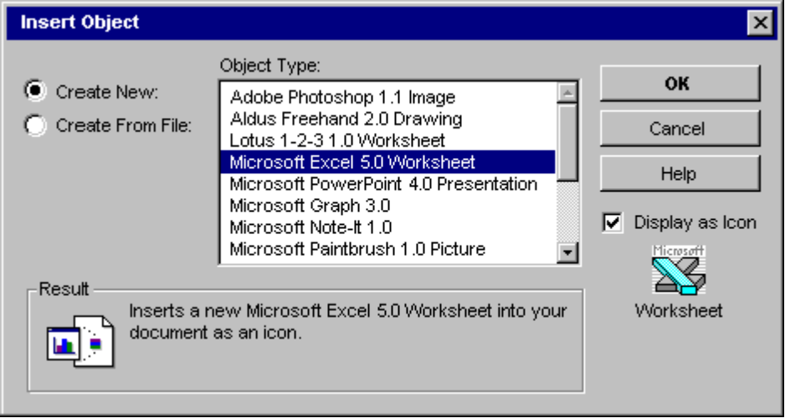

Figure 11.5 The Insert Object Dialog Box.
Note
The Microsoft Windows Software Development Kit includes the Insert Object dialog box and other OLE related dialog boxes that are described in this chapter.

Newly created objects can make use of the current selection in the container and format themselves accordingly. For example, an inserted graph automatically could reflect the data in a selected table. The following guidelines are designed to ensure predictable insertion:

n If a newly inserted object is not based on the current selection, the new object replaces the selection.
n If the new object is automatically connected to the selection (for example, table data and a graph), the new object should be inserted in addition to the selection and the object becomes the new selection.
n If the object is based on, but will not remain connected to the selection, the new object's application (not the container application) determines whether or not to remove the given selection. In this case, the specific use of an object type determines whether to adding the object or replacing the current selection is more meaningful.

The user can also create an OLE embedded or linked object from an existing file, using the Create From File and Link options. Using the Create from File option button is essentially the same as directly copying or linking the file. When the user chooses the Create From File option button, the Object Type list is removed and a text box and Browse button appear in its place, as shown in Figure 11.6.

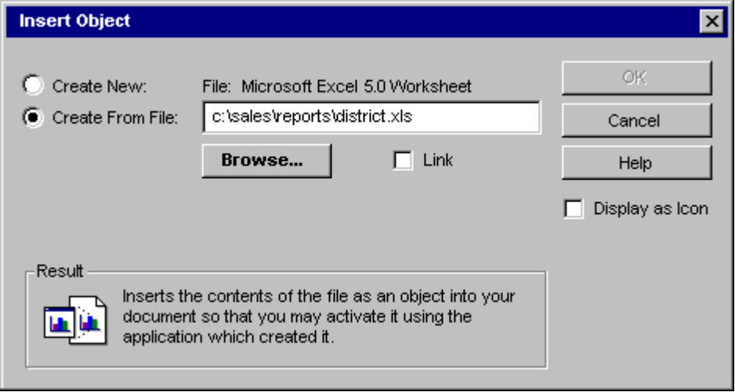

Figure 11.6 Options Set to Create an OLE Embedded Object from an Existing File.
The text box initially includes the current directory as the selection. The user can edit the current directory path when specifying a file. The file's type determines the type of embedded or linked object. A selection in the Object Type dialog box list (shown in Figure 11.5) is completely unrelated.
The Link check box supports the creation of an OLE linked object to the file specified and is only supported on the Create From File option. An object created from the type list using the Create New option button can only be inserted as an embedded object because the newly created object does not exist in another file. Only objects created from existing files can be inserted as linked objects.

The Display As Icon check box in the Insert Object dialog box allows the user to specify whether to display the embedded or linked object as an icon. When this option is set, the icon appears beneath the checkbox. Creating a linked object and displaying as an icon is operationally the same as a shortcut icon.

Note
If the user chooses a non-OLE file for insertion, it may only be inserted as an icon. The result is an OLE package. An package is an OLE encapsulation of a file so that it can be embedded in an OLE container. However, because packages support limited editing and viewing capabilities, avoid having your file types converted into packages by making them OLE compatible.

At the bottom of the Insert Object dialog box, descriptive text and pictures describe the final outcome of the insertion. Table 11.2 outlines the syntax of descriptive text to use within the Insert Object dialog box.

Table 11.2 Descriptive Text for Insert Object Dialog Box
Function | Resulting Text
Create a new (embedded) object from a selected type. | "Inserts a new <object type name> into your document."
Create a new object from a selected type and display it as an icon. | "Inserts a new <object type name> into your document as an icon."
Create a new object based on a selected file. | "Inserts the contents of the file as an object into your document so that you may activate it using the application which created it."
Create a new object based on a selected file and display it as an icon. | "Inserts the contents of the file as an object into your document so that you may activate it using the application which created it. It will be displayed as an icon."
Create a new object that is linked to a selected file. | "Inserts a picture of the file contents into your document. The picture will be linked to the file so that changes to the file will be reflected in your document."
Create a new object that is linked to a selected file and display it as a Shortcut icon. | "Inserts aShortcut icon into your document which represents the file. The Shortcut icon will be linked to the original file, so that you can quickly open the original from inside your document."

After inserting an embedded object, activate it for editing. If you insert a linked object, do not activate the object.

For more information about editing embedded objects, see the section, "Editing Embedded Objects" later in this chapter."

Toolbar Buttons and Inserting Objects
Your software can also include toolbar buttons (or other controls) that directly insert objects. These buttons provide the same functionality as the Insert Object dialog box, but perform in a more efficient manner. Figure 11.7 illustrates two examples. The drawing button inserts a new blank drawing object; the graph button creates a new graph that uses the data values from a currently selected table.

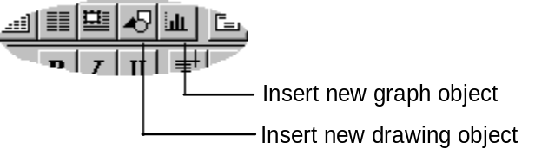
Figure 11.7 Toolbar Buttons Used for Creating New Objects.

Displaying Objects
When displaying an OLE embedded or linked object in its presentation or content form (as opposed to displaying the object as an icon), a cached metafile description is generally used (though it is possible for an object to draw itself directly in its container). In this presentation, the objec may be visually indistinguishable from native objects.

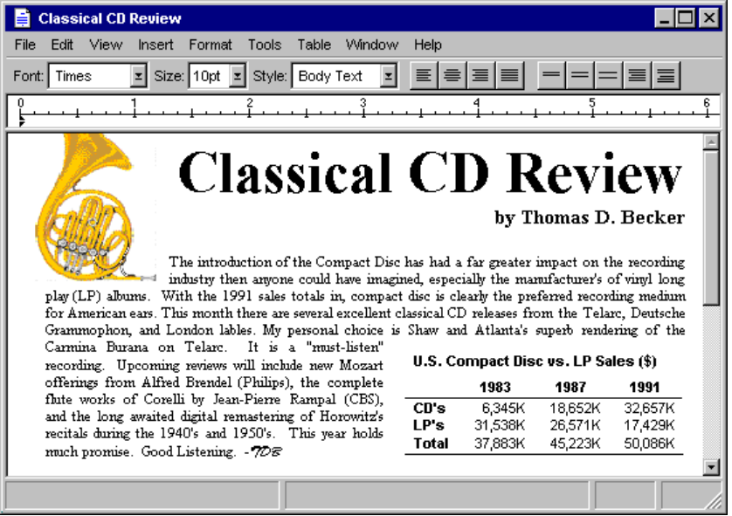

Figure 11.8 Document with Linked Picture and Embedded Worksheet Objects.
It may be desirable to allow the user to visually identify embedded or linked objects without interacting with them. Therefore, you can provide a "Show Objects" option
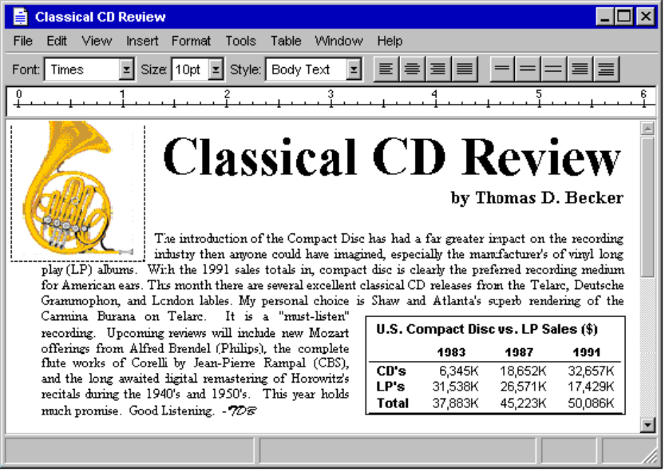

Figure 11.9 Linked and Embedded Objects After a Show Objects Command.
If these border conventions are not adequate to distinguish embedded and linked objects, your container can include additional distinctions; however, make certain that they are clearly distinct from the appearance for the other states, and that you distinguish embedded from linked objects.

Whenever the user creates an OLE linked or embedded object with the Display As Icon check box set, display the icon using its original appearance (unless the user explicitly changes it). A linked icon also includes the shortcut graphic. If an icon is not registered in the system registry for the object, use the system-generated icon.

A default label generally accompanies the icon. If the result is an embedded object, its default label should be one of the following:

n The name of the object, if the object has a name easily read by the user (for example, a filename without its extension).
n The object's registered short type name (for example, Picture, Worksheet, and so on), if the object does not have a name.
n The object's registered full type name (for example, Microsoft Paintbrush 1.0 Picture, Microsoft Excel 5.0 Worksheet), if the object has no name or registered short type name.
n “Document” if an object has no name, short type name, or registered type name.

For more information about registered type names, see Chapter 10, "Integrating with the System."

If a linked object is displayed as an icon, its default label is the source filename as it appears in the file system, preceded by the words "Shortcut to"; for example, "Shortcut to Annual Report." The path of the source is not included, but a user can view it in the property sheet of the object. The filename does not include an extension. If you link only a portion of a document (file) using the Paste Special or Paste Link commands, its default label is derived from its link path (moniker); this is generally sufficient to provide reasonable identification of the object.

Selecting Objects
An OLE embedded or linked object follows the selection behavior and appearance techniques supported by its containing document. For example, Figure 11.10 shows how the linked drawing of a horn is handled as part of a contiguous selection in the document
For more information about selection techniques, see Chapter 5, "General Interaction Techniques," and for information about selection appearance, see Chapter 13, "Visual Design."

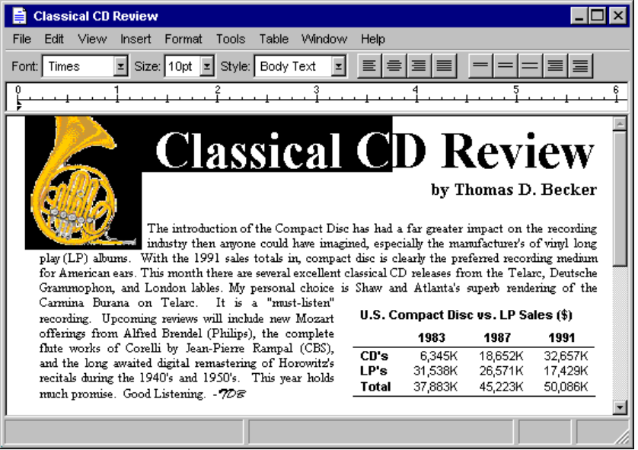

Figure 11.10 A Linked Object as Part of a Multiple Selection.
When the user individually selects the object, the container displays the object with an appropriate selection appearance for that type. For example, for the content view of an object, display it with handles. If the object is displayed as an icon, use the checkerboard selection highlighting used for icons in folders and on the desktop. For linked objects, overlay the content view's lower left corner with the shortcut graphic.

illustration of linked object with the shortcut graphic overlaid on the lower right handle

Figure #.# A linked Object Individually Selected.
For more information about handles and selection appearance, see Chapter 5, "General Interaction Techniques," and Chapter 13, "Visual Design."

Regardless of what selection appearance applies, the container application always supplies the selection appearance for embedded or linked objects that it contains.

Accessing Commands for Selected Objects
When a user selects an OLE embedded or linked object as part of the selection of native data in a container, the user may select and execute commands supported by the container application that apply to the selection as a whole. When the user individually selects the object, the container offers only operations that apply specifically to the object. The container can retrieve these operations from what has been registered by the object's type in the system registry. The container reflects these operations in the menus it supplies for the object. If the container includes a menu bar, it includes the selected object's commands on a submenu, such as the Edit menu, or as a separate menu on the menu bar. Use the name of the object in the menu entry. If you use the short type name as the name of the object, then add the word "Object" as shown in Figure 11.11. For a linked object, use the short type name, preceded by the word "Linked."

For more information on registering commands for object types, see Chapter 10, "Integrating with the System."

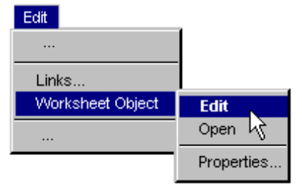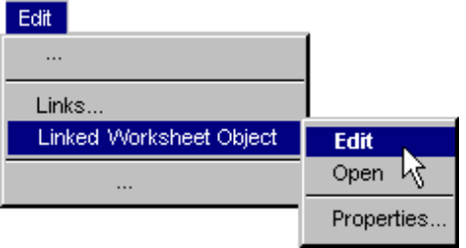

Figure 11.11 Selected Object Menus.
Define the first letter of the word "Object" (or its localized equivalent) as the access character for keyboard users. When no object is selected, display the command “Object” and disable it.

A container provides a pop-up menu for a selected object which is displayed using the standard interaction techniques for pop-up menus (clicking with mouse button 2). This menu includes the appropriate commands that the container can apply to the object as a whole, such as transfer commands, as well as the object's registered commands. In the pop-up menu, display the object's registered operations as individual menu items rather than in a cascading menu. It is not necessary to include the object's name or the word "Object." In addition, the container application provides a Properties command on the menu that provides access to the property sheet of the selected object.

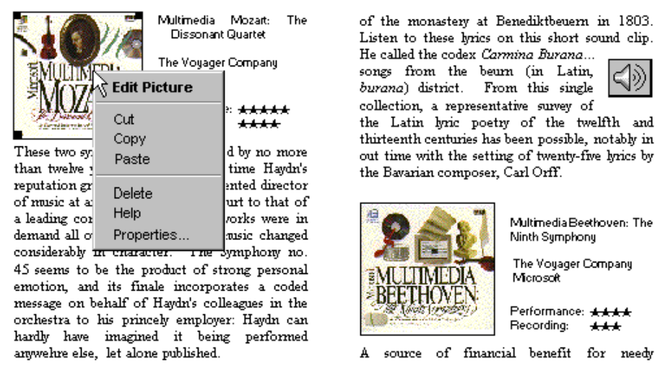

Figure 11.12 Pop-up Menu for an Embedded Picture in a Document.

Operations that depends on the state of the object can be enabled and disabled appropriately. For example, a media object that uses Play and Rewind as operations should disable Rewind when the object is at the beginning of the media object.

The container can also display the object with appropriate selection appearances, such as handles (for resizing or other operations), that affect the object as a unit with respect to the container.

Note When the user resizes a selected OLE object, it results in a scaling operation because there is no mechanism by which the container can communicate to the object that another operation such as cropping was used.

If the object's type is not registered, the container still supplies any commands that can be appropriately applied to the object as content, such as transfer command, alignment commands, and a Properties command. Also add a Open With command and set it as the default command for the object so that double-clicking executes the command. Open With displays a special dialog box that allows the user to choose from a list of applications to operate on the type or convert the object's type.

Displaying Messages for Selected Objects
If the window has a status bar that displays messages, display an appropriate description of how to activate the object when selecting an embedded or linked object. See Table 11.3, "File Menu Status Line Messages," later in this chapter for more information.

Activating Objects
While selecting an object provides access to commands applicable to the object as a whole, it does not provide access for the user to interact with the content of an object. Activating the object allows user interaction with the internal content of the object. There are two basic models for activating objects: outside-in activation and inside-out activation.

Outside-in Activation
Outside-in activation requires an explicit user action.Selecting an object that is already selected simply reselects that object and does not constitute an explicit action. The user can activate the object by using a particular command (usually its default command), such as Edit or Play. Shortcut actions that correspond to these commands, such as double-clicking or pressing a shortcut key, can also activate the object.

Most OLE containers employ this model because it allows the user to easily select objects and reduces the risk of inadvertently activating an object whose underlying code may take a significant amount of time to load and dismiss. Containers display the standard pointer (northwest arrow) over outside-in activated objects when they are not active. This indicates that the outside-in object behaves as a single, opaque object.

Inside-out Activation
Using inside-out activation, interaction with an object is direct. From the user's perspective, inside-out objects are indistinguishable from native data, because the content of the object is directly interactive and no additional action is necessary. Use this method for the design of objects that benefit from direct interaction, or because the impact of activating the object is small for performance or use of system resources.

Inside-out activation requires closer cooperation between the container and the object. For example, if the user begins a selection within an inside-out object, the container needs to clear its own selection so that the behavior is consistent with normal selection interaction. An object supporting inside-out activation controls the appearance of the pointer as it moves over its extent and responds immediately to input. Therefore, to select the object as a whole, the user selects the border or some other handle provided by its container.

The default behavior for an OLE embedded object is outside-in activation. But information can be registered in the system registry that indicates that an object's type (application class) is capable of inside-out activation (the OLEMISC_INSIDEOUT flag) and prefers inside-out behavior (the OLEMISC_ACTIVATEWHENVISIBLE flag).

Container Control of Activation
A container still determines how to activate its component objects: whether it allows the inside-out objects to handle events directly or whether it intercedes and only activates them upon an explicit action. That is, even though an object may register inside-out activation, it can be treated by a particular container as outside-in. A container uses an activation style that is most appropriate for its specific use and is in keeping with its own native style of activation so that objects can be easily assimilated.
For more information about OLE and the system registry, see the Microsoft Windows Software Development Kit.

Regardless of the activation capability of the object , a container always activates its content objects of the same type consistently. Otherwise, the unpredictability of the interface is likely to impair its ease of use. The following are four examples of potential container activation strategies:

Activation method | When to use
Outside-in throughout | This is the typical case for containers that often embed large objects and treat them as whole units. Because OLE documents are a popular expression of OLE and many of the available objects are not inside-out capable, to preserve uniformity, most document-type containers use outside-in throughout. This is likely to continue as the common convention until more inside-out objects are available.
Inside-out throughout | The long term direction is to blend embedded objects with native data to eliminate the distinction. Inside-out throughout containers will become more feasible as increasing numbers of OLE objects support and prefer inside-out activation.
Outside-in plus  inside-out preferred objects | Some containers use an outside-in model for large, foreign embeddings but also include some inside-out preferred objects as though they were native objects (by supporting the OLEMISC_ACTIVATE_WHEN_VISIBLE preference). For example, an OLE document might present form control objects as inside-out native data while at the same time activating larger spreadsheet and chart objects as outside-in.
Switch between inside-out throughout and outside-in throughout | Some programming and forms layout design applications have design and run modes. In this type of environment, a container typically holds inside-out capable (if not preferable) objects and alternates between outside-in throughout when designing and inside-out throughout when running.

OLE Visual Editing of Embedded Objects
One of the most common uses for activating an object is for editing its content in its current location. Supporting this type of in-place interaction is also called OLE visual editing, because the object can be edited within the visual context of its container.

Unless the container and the object both support inside-out activation, the user activates an embedded object for editing by selecting the object and executing its Edit operation, either from a drop-down or pop-up menu. You can also support shortcut techniques. For example, if Edit is the object's default operation, you can use double-clicking to activate the object for editing. Similarly, you can support pressing the enter key as a shortcut for activating the object.

Note
Formerly, OLE 2.0 UI documentation suggested using the alt+enter key combination to activate an object if the enter key was already used. However, the alt+enter key combination is now the recommended shortcut key for the properties command. Alternatively, OLE embedded objects can be activated from the keyboard by supporting the pop-up menu shortcut key, shift+f10. Then the user can select the activation command from the pop-up menu.

When the user activates an embedded object for OLE visual editing, the user interface for its content becomes available and must be appropriately blended into its container's interface. The object can display its frame adornments, such as row or column headers, handles, or scroll bars, outside the extent of the object and temporarily cover neighboring material. It can also change the menu interface, which can range from adding menu items existing drop-down menus to replacing entire drop-down menus. Toolbars, status bars, and supplemental palette windows can be added.

The degree of blending varies based on the nature of the embedded object. Some embedded objects may require extensive support and consequently result in dramatic changes to the container's interface. Finer grain objects that emulate native components of a container may require little or no need to make changes in the container's user interface. The container determines the degree an embedded object's interface can be blended with its own, regardless of the capability or preference of the embedded object. A container that provides its own interface for an embedded object can suppress an embedded object's own interface. Figure 11.13 shows how the interface might appear when its embedded worksheet is activated.

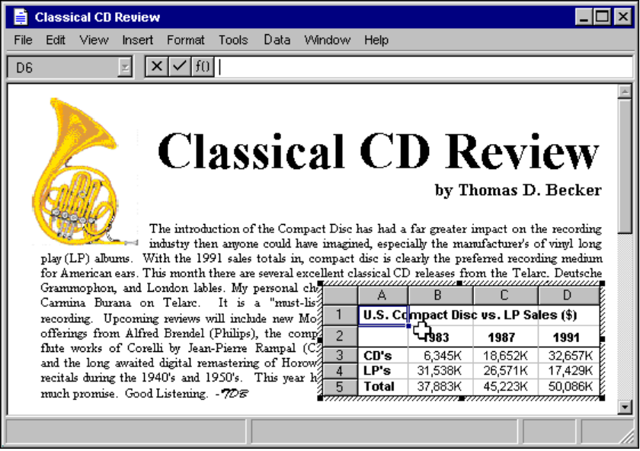
Figure 11.13 A Worksheet Activated for OLE Visual Editing.
When the user activates an embedded object, avoid changing the view and position of the rest of the content in the window. While it may seem reasonable to scroll the window, preserving the content’s position, the user’s focus is not disturbed by the active object shifting down to accommodate a new toolbar and shifting back up when it is deactivated. The exception may be when the activation exposes an area that the container has nothing to display. However, even in this situation it is possible for the container to render a visible region or filled area that corresponds to background area outside the visible edge of the container.

Activation does not affect the title bar. It always displays the top-level container's name. For example, when the worksheet shown in Figure 11.13 is activated, the title bar continues to display the name of the document in which the worksheet is embedded and not the name of the worksheet. You can provide access to the name of the worksheet by supporting property sheets for your embedded objects.

For more information about property sheets for embedded objects, see "Using Property Sheets" later in this chapter.

A container can contain multiple nested embedded objects. However, only a single level is active at any one time. Figure 11.14 shows a document containing an active embedded worksheet with an embedded graph of its own. Clicking on the graph merely selects it as an object within the worksheet.

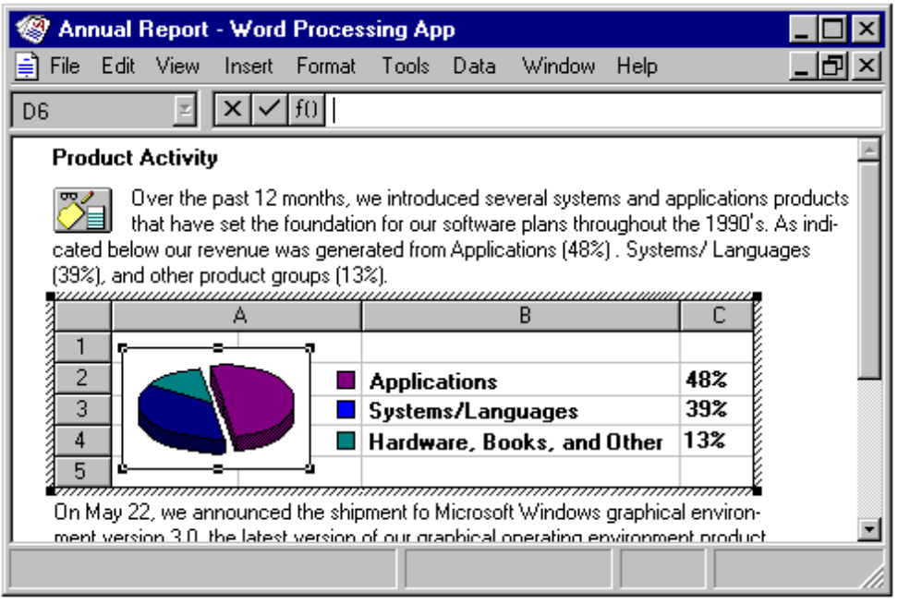

Figure 11.14 A Selected Graph Within an Active Worksheet.
Activating the embedded graph, for example, by selecting the graph's Edit operation, activates the object for visual editing, displaying the graph’s menus in the document's menu bar. At any given time, only the interface for the currently active object and the topmost container is presented; intervening parent objects do not remain visibly active.

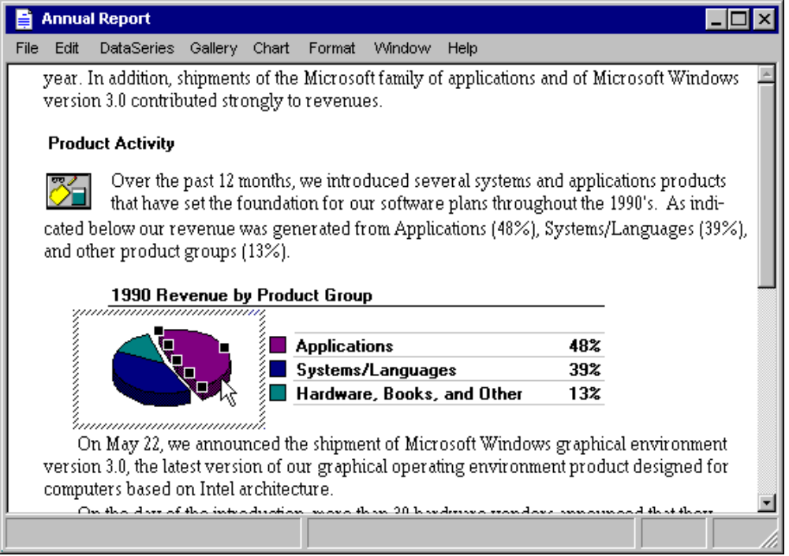

Figure 11.15 An Active Graph Within a Worksheet.
Note Ideally, an OLE embedded object supports visual editing at any scale because its container may be arbitrarily scaled. If an object cannot accommodate visual editing in its container's current view scale, or if its container does not support visual editing, the object should open into a separate window for editing. For more information about embedded objects, see "Opening an Embedded Object" later in this chapter.

An interaction, such as selection outside the extent of an active object or activation of another object in the container, deactivates the current object and gives the focus to the new object. This is also true for an object that is nested in the currently active object. The user can also deactivate an active object by pressing the esc key. If an object uses the esc key at all times, use shift+esc to deactivate the object, after which it becomes the selected object of its container.

Edits made to an active object become a part of the container immediately and automatically, just like edits made to native data. Consequently, do not display an “Update changes?” message box when the object is deactivated. Of course, changes to the entire container, embedded or otherwise, can be abandoned if the topmost container includes an explicit commands that prompt the user to save or discard changes to the container's file.

Embedded objects participate in the undo stack of the window in which they are activated. For more information about embedded objects and the undo stack, see the section "Undo for Active and Open Objects" later in this chapter.

While Edit is the most common command for activating an embedded object for OLE visual editing, other commands can also create such activation. For example, when the user executes a Play command on a video clip, you can display a set of controls that allows a user to control the clip (Rewind, Stop, Fast Forward). In this case, the Play command provides a form of OLE visual editing.

The Active Hatched Border
If a container allows an OLE embedded object's user interface to have a significant impact on its own user interface, then the active object displays a hatched border around itself to show the extent of the OLE visual editing context. That is, if an active object's menus appear in the topmost container's menu bar (the object's request is granted by the container), then display the active hatched border. If the object's menus do not appear in the menu bar (because the object did not request that or because the container refused its request) or the object is otherwise accommodated by the container's user interface, it is not necessary to display the hatched border.

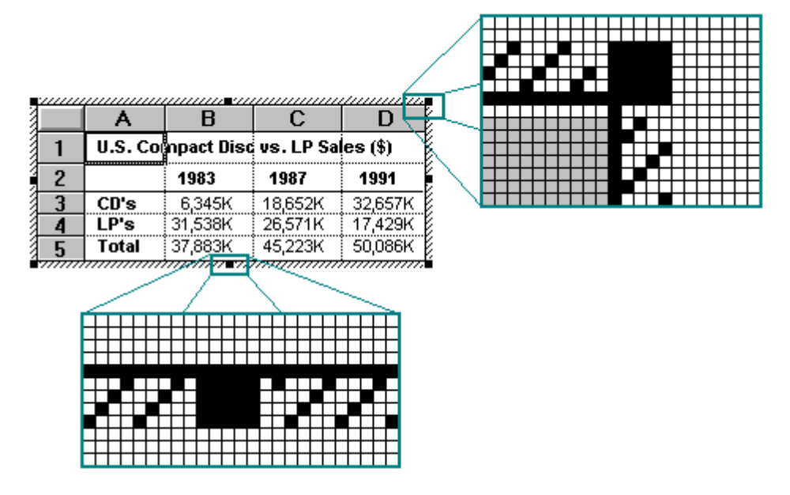

Figure 11.16 Hatched Border Around In-Place Activated Objects.
The hatched pattern is made up of 45-degree diagonal lines. The active object takes on the appearance which is best suited for its own editing; for example, frame adornments, table gridlines, handles, and other editing aids can appear. The hatched border is part of the object's territory, so the pointer that appears when the mouse is over the border is defined by the active object.

Clicking in the hatched pattern (and not on the handles) is interpreted by the object as clicking just inside the edge of the border of the active object. The hatched area is effectively a hot zone that prevents inadvertent deactivations and makes it easier to select the content of the object.

Menu Integration
As the user activates different objects, different commands need to be accessed through the user interface. The following classification of menus separates the interface based on menu groupings. This classification enhances the usability of the interface by defining the interface changes as different objects are activated or deactivated.

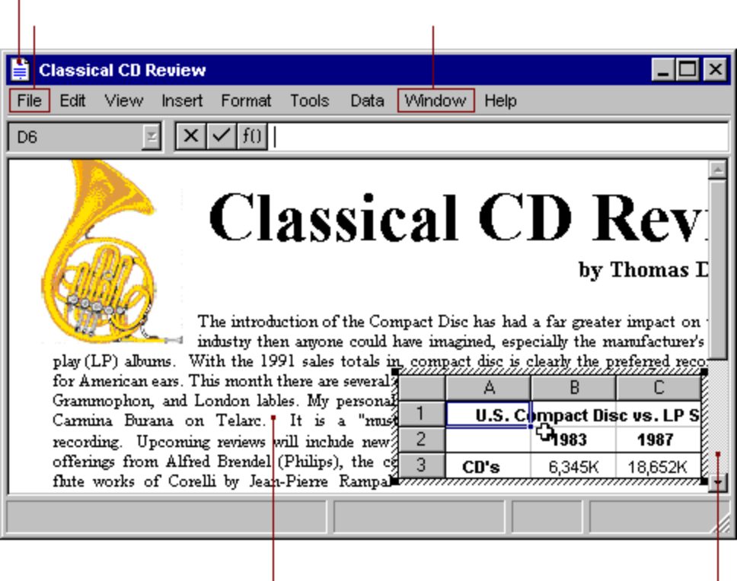
Figure 11.17 Container Interface Components.

Primary Container Menu
The topmost or primary container being viewed in a primary window controls the work area of that window. If the primary container includes a menu bar, it supplies a single menu that includes commands that apply to the primary container as an entire unit. For document objects, a File menu is typically used for this purpose. This menu includes document and file level commands such as Open, Save, and Print.
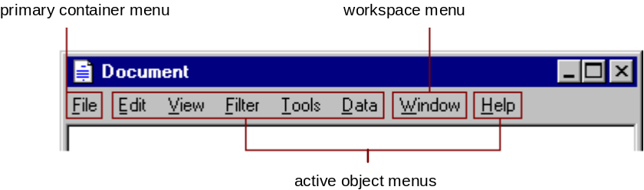

Figure 11.18 OLE Visual Editing Menu Layout.

Workspace Menu
A multiple document interface-style application should also include a workspace menu (typically labeled "Window") on its menu bar that provides commands for managing the document windows displayed within it. The primary container menus remain in the menu bar at all times, no matter which object is active.

For more information about the multiple document interface (MDI), see Chapter 9, "Window Management."

Active Object Menus
Active objects can define menus that appear on the primary container's menu bar that operate on their content. You can place commands for moving, deleting, searching and replacing, creating new items, applying tools, styles, and Help on these menus.

Active object commands apply only within the extent of the object. An active object's menus typically occupy the majority of the menu bar. Organize these menus the same as when the object is opened into a separate window. As the name suggests, active object commands are executed by the currently active object (which may be the top container). Avoid naming active object menus File or Window because primary containers often use those titles. Objects that use direct manipulation as their sole interface need not provide active object menus or alter the menu bar when activated.

A View menu is categorized as an active object menu and holds viewing commands which only apply within the active object. If a container wishes to keep its document or window-level “viewing” commands available while an object is active, it locates them on a workspace menu, preferably the Window menu, if it is present.

The interface of selected objects within an active object follow the same guidelines as that of a primary container and one of its selected embedded objects; that is, the commands of the selected object (as registered in the system registry) become available either as a submenu of the current active container object or as a separate menu, as well as on the selected object's pop-up menu.

An active object also has the responsibility for defining and displaying the pop-up menu for its content, specifically commands appropriate to apply to any selection within it. Figure 11.19 illustrates an example of a pop-up menu for a selected bitmap picture.

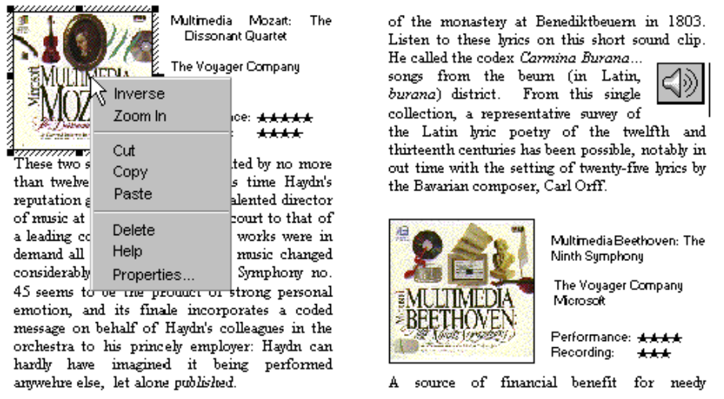

Figure 11.19 Example of a Pop-up Menu for a Selection in an Active Picture Object.

Keyboard Interface Integration
In addition to integrating the menus, all of the access keys and shortcut keys used in these menus must be integrated as well.

Access Keys
The access keys assigned to the primary container's menu and an active object's menus and MDI workspace menus should be unique. The following are guidelines for defining access keys for integrating these menu names.

n Use the first letter of the menu of the primary container as its access key character. Typically, this will be "F" for File. Use "W" for a workspace's Windowmenu . Localized versions should use the appropriate equivalent.
n Use characters other than those assigned to the primary container and workspace menus for the menu titles of active embedded objects. (If an embedded object has previously existed as a standalone document, its application avoids these characters already.)
n Define unique access keys for an object's registered commands and avoid characters that are potential access keys for common container-assigned commands, such as Properties.
Despite these guidelines, if the same access character is used more than once, pressing alt+<letter> will cycle through the candidates highlighting the next match each time it is pressed. To execute the command, the user must press the enter key when it is highlighted. This is standard system behavior for menus.

For more information about defining access keys, see Chapter 4, "Input Basics."

Shortcut Keys
Both primary containers and active objects (that is, their application code) should follow the shortcut key guidelines covered in this guide. In addition, avoid defining shortcut keys for active objects that are likely to be assigned to the container. Include the standard editing and transfer (Cut, Copy, Paste) shortcut keys, but avoid File menu or system-assigned shortcut keys. There is no provision for registering shortcut keys for a selected object's commands.

For more information about defining shortcut keys, see Chapter 4, "Input Basics," and Appendix B, "Keyboard Interface Summary."

If a container and an active object share a common shortcut key, the active object captures the event. That is, if you activate an embedded object, its application code directly processes the shortcut key. If the active object does not process the key event, then it is available to the container which also has the option to process it or not. This applies to any level of nested embedded objects. If there is a duplication between shortcut keys, the user can always direct the key based on where the active focus is by activating that object. To direct a shortcut key to the container, the user deactivates an embedded object, for example, by selecting in the container, but outside the embedded object. Activation, not selection, of an embedded object allows it to receive the keyboard events. (The exception is inside-out activation where activation results from selection.)

Toolbars, Frame Adornments, and Palette Windows
Integrating drop-down and pop-up menus is straightforward because they are confined within a particular area and follow some standard conventions. Toolbars, frame adornments, and palette windows may be less predictably constructed so it is best to follow a replacement strategy when integrating these elements for active objects. That is, toolbars, frame adornments, and palette windows are displayed and removed as entire sets rather than integrated at the individual control level just like menus on the menu bar.

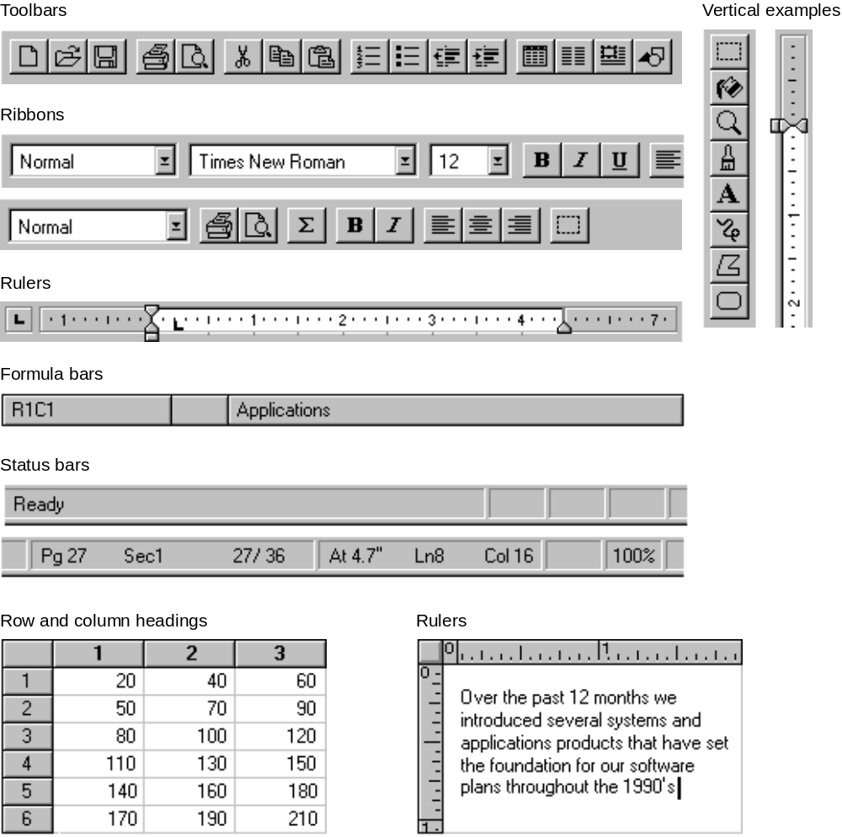
Figure 11.20 Examples of Toolbars and Frame Adornments.

When an object becomes active, it requests a specific area from its container in which to post its tools. The container determines whether to:

n Replace its tool (or tools) with the tools of the object, if the requested space is already occupied by a container tool.
n Add the object’s tool (or tools), if a container tool does not occupy the requested space.
n Refuse to display the tool (or tools) at all. This is the least desirable.
Toolbars, frame adornments, and palette windows are all basically the same interfaces — they differ primarily in their location and the degree of shared control between container and object. There are four locations in the interface where these types of controls reside, and the choice of its location is principally determined by the scope.

Location | Description
Object frame | Place object-specific controls, like a table header or a local coordinate ruler, directly adjacent to the object itself for tightly coupled interaction between the object and its interface. An object (such as a spreadsheet) can include scrollbars if its content extends beyond the boundaries of its frame.
Pane frame | Locate view-specific controls at the pane level. Rulers and viewing tools are common examples.
Document (primary container) window frame | Attach tools that apply to the entire document (or documents in the case of an MDI window) just inside any edge of its primary window frame. Popular examples include ribbons, drawing tools, and status lines. .
Windowed | Display tools in a palette window above a document — this allows users to arrange them as desired. A palette window typically floats above the primary window and any other windows of which it is a part.

For more information about the behavior of palette windows, see Chapter 8, "Secondary Windows."

When designing where to locate a tool area, avoid situations that would cause the view to shift up and down as different sized tool areas are displayed or removed as different objects activate. This can be disruptive to the user's task.

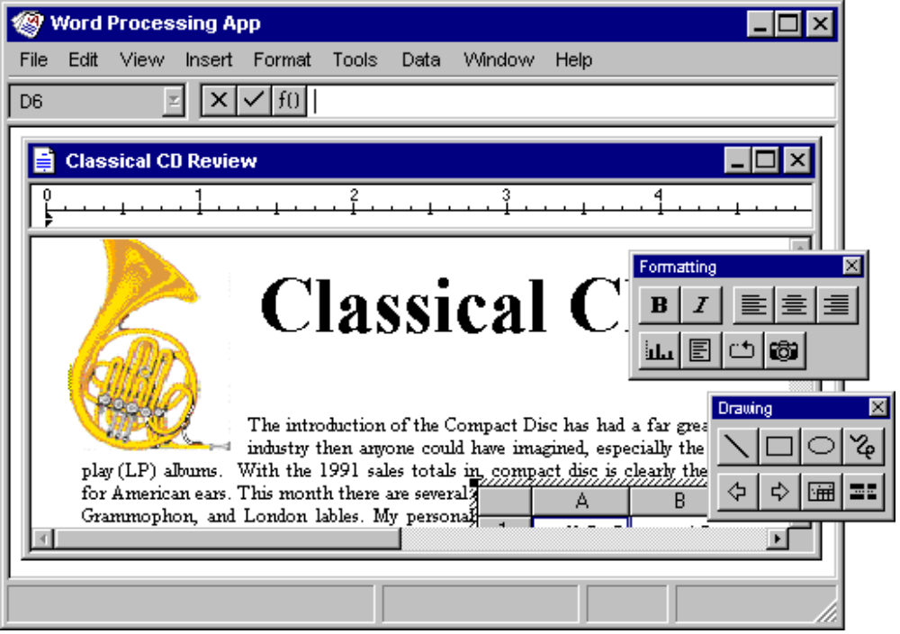
Figure 11.21 Four Possible Positions for Interface Controls.
Because container tool areas can remain visible while an object is active, they are available to the user simply by interacting with them, which can reactivate the container application. The container determines whether to activate or to leave the object active. If the tool area of an active object contains primary container or workspace commands such as Save, Print, or Open, they must be disabled.

For more information about the negotiation protocols used for activation, see the OLE reference documents in the Microsoft Windows Software Development Kit.

As the user resizes or scroll the window, an active object and its toolbar or frame adornments placed on the object frame are clipped by its immediate window pane, just like all container content. These interface control areas lie in the same plane as the object. When the object is clipped, the user can edit the visible part of the object in-place and the visible frame adornments are operational.

Some container applications scroll at certain increments that prevent portions of an embedded object from being visually edited. For example, consider a large picture embedded in a worksheet cell. The worksheet scrolls vertically in complete row increments — the top of the pane is always aligned with the top edge of a row. If the embedded picture is too large to fit within the pane at one time, then its bottom portion is clipped and consequently never viewed or edited in-place. In cases like this, the user can open the picture into its own window for editing.

Window panes clip frame adornments of nested embedded objects, but not by the extent of any parent object. Objects at the very edge of their container's extent or boundary potentially display adornments that extend beyond the bounds of the container's defined area. In this case, if the container displays items that extend beyond the edge, it should display all the adornments; otherwise, clip the adornments at the edge of the container. The container does not temporarily move the object with respect to the content just to accommodate the appearance of the adornments. A pane level control can be potentially clipped by the primary (or parent, in the case of MDI) window frame , and a primary window adornment or control is clipped by other primary windows.

Opening OLE Embedded Objects
The previous sections have focused on OLE visual editing; that is, editing an OLE embedded object in-place; that is, in its current location. However, as an alternative, a user can also open embedded objects into their own window. This gives the user the opportunity of seeing more of the object, or seeing the object in a different view state. Support this operation by registering an Open command for the object. When the user chooses the Open command of an object, it opens it into a separate window for editing.

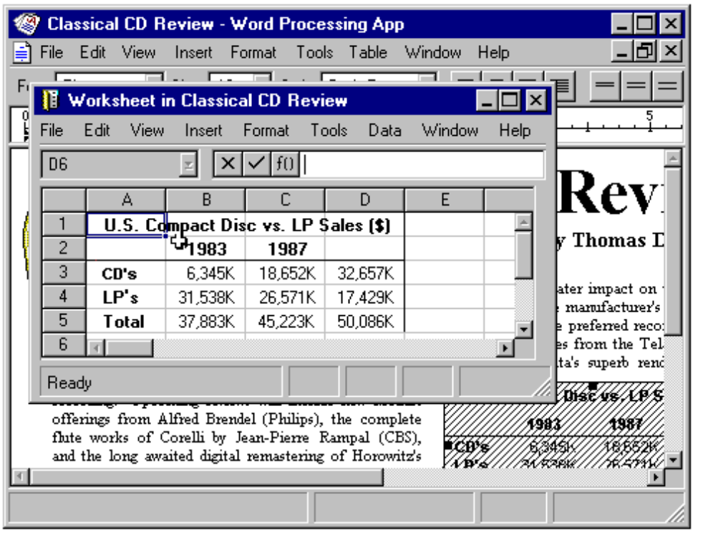

Figure 11.22 An Opened Worksheet.
After opening an object, its container displays itmasked with an "open" hatched (45 degree lines) pattern that indicates the object is open in another window.

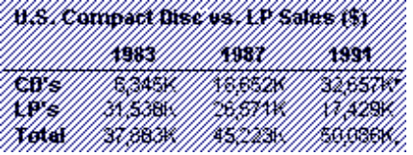

Figure 11.23 An Opened Object.
The format for the open object’s window title is "<object name> in <container name>" (for example, “Sales Worksheet in Classical CD Review"). Including the container's name to emphasizes that the object in the container and the object in the open window are considered the same object.

OLE presents an open embedded object as an alternate window onto the same object within the container as opposed to a separate application that updates changes to the container document. Therefore, edits are immediately and automatically reflected in the object in the document, and there is no longer the need for the update confirmation upon exiting the open window.
Nevertheless, you may still include in the window's of open objects an Update <Source File> command to allow the user to explicitly request an update. This is useful if you cannot support frequent “real-time” image updates because of overall system performance. In addition, when the user closes a open object's window, automatically update it in the container's window. You can also include Import File and similar commands in the window of the open object. Importing an file into the window of the open embedded object is conceptually the same as any change to the object.

At the point when the user opens an object, it is the selected object in the container ; the selection in the container may be changed afterwards. Like selected embedded objects, the container supplies the appropriate selection appearance together with the open appearance. However, if the user chooses to print the container with while an embedded object is open or active, use the presentation form of objects; neither the open nor active hatched patterns should appear in the printed document because these are not part of the content.

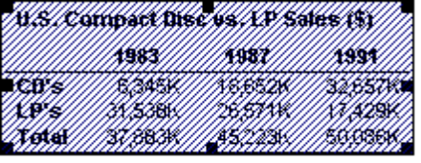

Figure 11.24 Selected Open Object.
While an embedded object is open, it is still a functioning member of its container. It can still be selected or unselected, and respond to appropriate container commands. At any time, the user may open any number of embedded objects. The object is deactivated and its window is closed when the user closes its container window.

When opening an embedded object, if it has file operations such as Open, remove these in the resulting window, or replace them with a command like Import, to avoid severing the object's connection with its container. The objective is to present a consistent conceptual model that the object in the opened window is the same as the one in the container. Editing an OLE Linked Object
An OLE linked object is itself an object in that it can be stored in a particular location, moved or copied, and have its own properties. Container actions can be applied in as much as the linked object acts as a unit of content. So an OLE container must supply commands, such as Cut, Copy, and Properties, and interface mechanisms such as handles, menus (menu bar and pop-up), and property sheet, for the linked objects it contains.

For more information about providing access to selected OLE objects, see the section, "Accessing Commands for Selected Objects", earlier in this chapter.

The container also provides access to the commands that activate the linked object, including the commands that allow the content the linked object represents to be edited. These commands are the same as those that have been registered for the link source's type. Because an OLE linked object represents or provides access to another object that resides elsewhere, editing the content of a linked object always takes the user back to the link source's location where the editing takes place.Therefore, the command used to edit an OLE linked object is the same as the command of its link source object. For example, the menu of a linked object can include both Open and Edit if its link source is an OLE embedded object. The Open command opens of the embedded object, just as executing the command on the embedded object does. The Edit command opens the window of the container of the embedded object, and activates the object for visual editing.

Figure 11.25 shows how the linked horn drawing appears in its own window for editing. It is important to note that changes made to the horn will be reflected not only in its host container, the "Classical CD Review" document, but in every other document that is linked to that same portion of the "Horns" document. This illustrates the power and the potential danger of using links in documents.
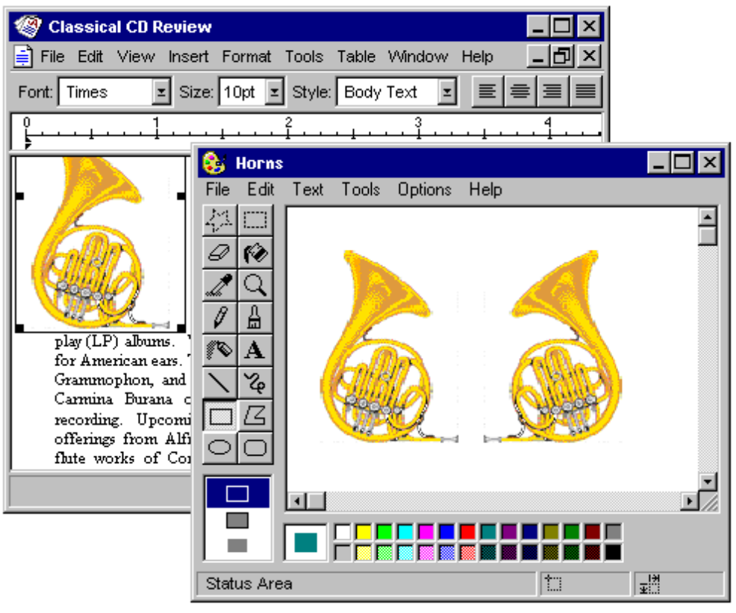

Figure 11.25 Editing a Link Source.
At first glance, editing a linked object seems to have the same open editing appearance as an embedded object. A separate primary window opens displaying the data. Note, however, that the horn does not have the open hatched pattern, nor does the second window's title bar indicate that the object is within "Classical CD Review." The object is actually in a completely independent document. In addition, the container should display a link-loading message to indicate that the source document is loading.

Automatic and Manual Updating
When the user creates an OLE link, by default it is an automatic link; that is, whenever the source data changes, the link’s visual representation changes without requiring any additional information from the user. Therefore, you do not display an “Update Automatic Links Now?” message box, but you candisplay a message box indicating the progress of the update if the update takes significant time to complete.

If users wish to exercise control over when links are updated, they can set the linked object’s update property to manual. Doing so requires that an explicit command to update the link representation or as a part of a container's “update fields” or “recalc” action.

For more information about updating links automatically or manually, see the section "Maintaining Links" later in this chapter.

Operations and Links
The operations available for an OLE linked object are those supplied by its container and those supplied by its source. When the user chooses a command supplied by its container, the container application handles the operation. When a user chooses a command supplied by its source, the operation is conceptually passed back to the source object for processing. In this sense, activating a linked object actives its source object. In certain cases, the linked object exhibits the result of an operation; in other cases the source object can be brought to the top of the Z-order to handle the operation. For example, executing operations such as Play or Rewind on a link to a sound recording appear to operate on the linked object in-place. However, if the user chooses a command to alter the link's representation its source's content (such as Edit or Open), the link's source is exposed and responds to the operation instead of the linked object itself. A link may play in-place, but not be edited in-place. In order for a link source to properly respond to editing operations, the source object is fully activated (with all of its containing objects and its container). The common case is when the user double-clicking a linked object whose default operation is Edit. The source (or its container) opens, displaying the link source object ready for editing. If the source is already open, then the window displaying the source becomes active. This follows the standard convention for activating a window already open; that is, the window comes to the top of the Z-order. If necessary, you can adjust the view in the window, scrolling, or changing focus within the window, as necessary, to present the source object for easy user interaction. .The link source window and linked object window operate and close independently of each other.

Note
If a link's source is contained within a read-only document, the results of editing the source cannot be saved.

Types and Links
An OLE linked object includes a cached copy of its source’s type at the time of the last update. When the type of a link's source object changes, all links derived from that source object will contain the old type and operations until either an update occurs or the link source is activated.. Because out-of-date links can potentially display obsolete operations to the user, a mismatch can occur. When executing an operation on a link object, the link object compares the cached type with the current type of the link source. If they are the same, the linked object forwards the operation on to the source. If they are different, the linked object informs its container. In response, the container can either:

n Execute the new type's operation, if the operation issued from the old link is syntactically identical to one of operations registered for the source’s new type.
n Display a message box, if the issued operation is no longer supported by the link source’s new type.
For more information about message boxes, see the section "Message Boxes" later in this chapter.

In both cases, the link adopts the source’s new type and subsequently the container displays the new type's operations in the linked object's menu.

Maintaining Links
An OLE linked object has three properties: its type (or class), the name of its source data, and its updating basis, which is either automatic or manual. Include these on a Link page in the linked object's property sheet supplied by the container. A container application can supply a Links command that displays a dialog box for altering the properties of several links together.

For more information about property sheets for OLE objects, see the section "Using Property Sheets" later in this chapter.

Note
The Microsoft Windows Software Development Kit includes the Links dialog box and other OLE related dialog boxes that are described in this chapter.

Figure 11.26 shows the Links dialog box. The list box in the dialog box displays the links in the container. Each line in the list contains the link source's name, object type (short type name), and whether it updates automatically or manually. If a link source cannot be found, “Unavailable” appears in the update status column.

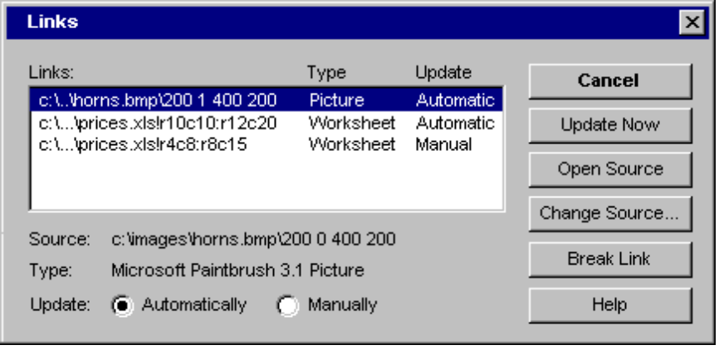

Figure 11.26 The Links Dialog Box.
If the user chooses the Links command when the current selection includes a linked object (or objects), then display that link (or links) as selected in the Links dialog box and scroll the list to display the first selected link at the top of the list box.

Allow 15 characters for the short type name field, and enough space for Automatic and Manual to appear completely. As the user selects each link in the list, its type, name, and updating basis appear in their entirety at the bottom of the dialog box. Command buttons provide support for the following link operations:

n Break Link effectively disconnects the selected link.
n Update Now forces the selected link to connect to its sources and retrieve the latest information.
n Open Source opens the link source for the selected link.
n Change Source invokes a dialog box similar to the common Open dialog box to allow the user to respecify the link source.

Set the Open Source button to be the default command button when the input focus is within the list of links. Also support double-clicking an item in the list as a shortcut for opening that link source..

The Change Source button allows the user to change the source of a link by selecting a file or typing in a filename. The user can enter a source name that does not designate a presently existing object. When the user chooses OK, display a message box with the following message in Figure 11.27.

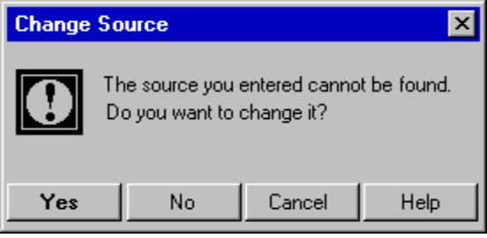

Figure 11.27 Invalid Source Message Box.
If the user chooses Yes, display the Change Source dialog box to correct the string. If the user chooses No, store the unparsed display name of the link source until the user successfully causes the link to connect to a newly created object that satisfies the dangling reference. The container application may also choose to allow users to connect only to presently valid links. If the user chooses Cancel remove the message box and return input focus to the Links dialog box.

If the user change a link source, and other linked objects in the same container are connected to the same original link source, provide a user option to make the changes for the other references. Figure 11.28 shows how a message box can be used to allow users to redirect links , such as when the link source's directory or filename has been changed.

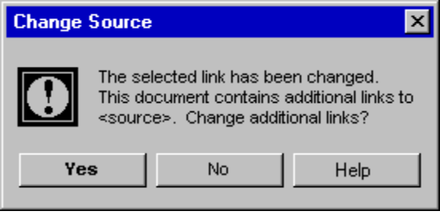

Figure 11.28 Changing Additional Links with Same Source.

Using Handles
A container displays handles for an OLE embedded or linked object when the object is individually selected. When an object is selected and not active, only scaling of the object (its cached metafile) can be supported. If a container uses handles for indicating selection, but does not support scaling of the image, then use the hollow form of handles.

For more information about the appearance of handles, see Chapter 13, "Visual Design."

When an embedded object is activated for OLE visual editing, it displays it own handles. The active object also determines what operation to support when the user drags a handle. Display the handles within the active hatched pattern.

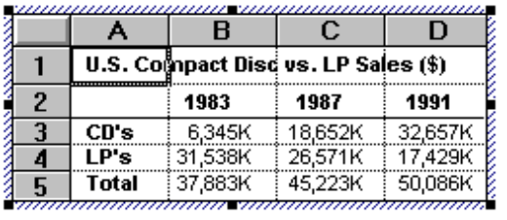

Figure 11.29 In-place Resizing.
While the interpretation of the handle dragging operation depends on the type of the embedded object, the recommended operation is cropping; that is, exposing more or less of the embedded object's content, adjusting the viewport rather than scaling the object's appearance. The default operation for certain objects, however, is in-place scaling if cropping is not meaningful. If no operation is meaningful, but handles are required to indicate selection while activated, use the hollow handle appearance.

Using Property Sheets
Like other types of objects, when the user selects an OLE embedded or linked object, provide user access its properties through a Properties command. If the container application already uses some kind of Properties command for its own native data, it can also be used for selected embedded or linked objects. Otherwise, add the command to the Object submenu beneath a separator. In addition, include the Properties command at the bottom of an object’s pop-up menu.

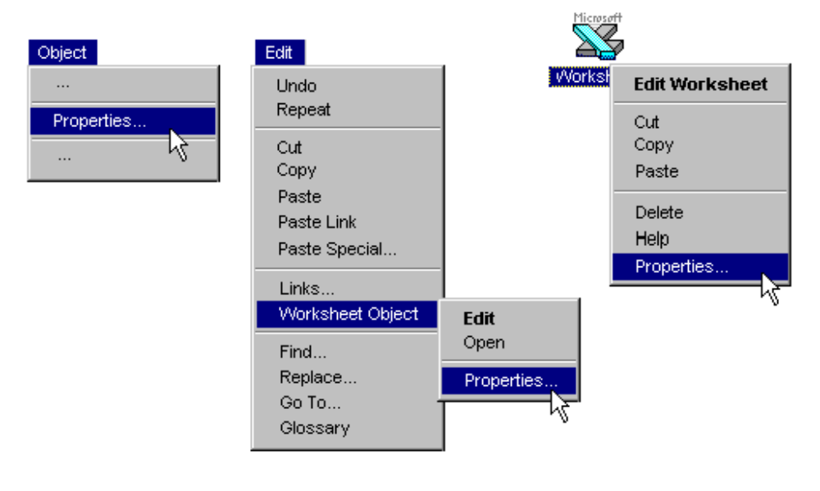

Figure 11.30 The Properties Command.
When the user chooses the Properties command, the container displays a property sheet containing all the salient properties and values for the selected object. In general, organize properties by categories or topics. Figure 11.31 shows possible property sheet's for an embedded and linked worksheet object.

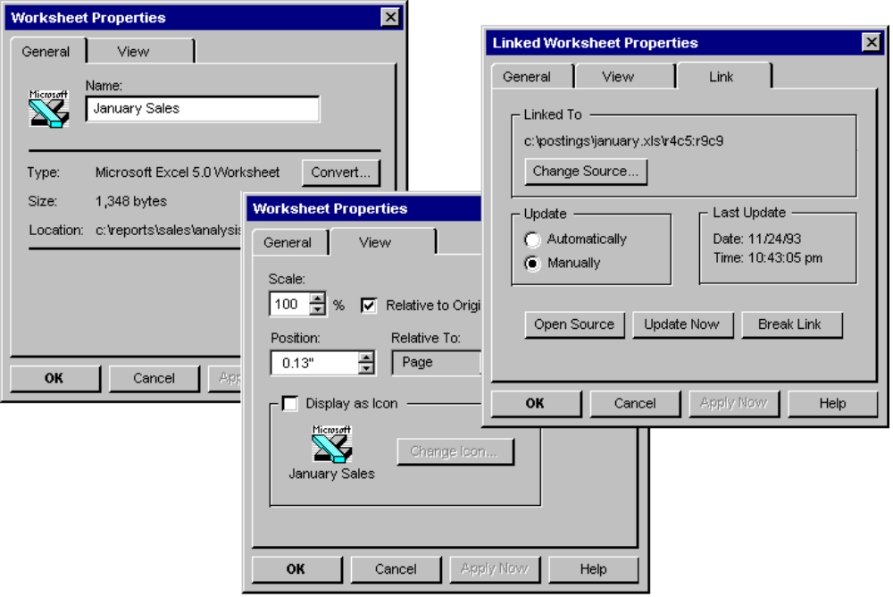
Figure 11.31 Embedded and Linked Object Property Sheets.
For linked objects include a Link page in its property sheet containing the essential link parameters. For the typical OLE link, this includes the source name, Change Source command, Update setting (automatic or manual), Last Update timestamp, Open Source, Update Now, and Break Link commands.

Type Conversion
To support the user converting an OLE object from its current type to another registered type, provide a Convert dialog box as pictured in Figure 11.32. The user accesses the Convert dialog box by including a Convert button beside the “Type” field in an object’s property sheet.

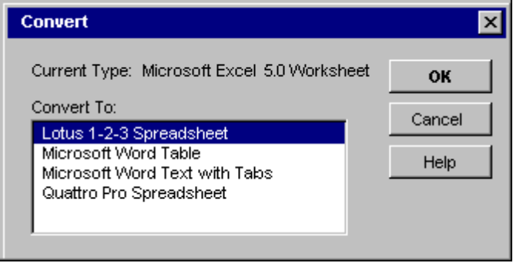

Figure 11.32 The Convert Dialog Box.
This dialog box displays the current type of the object and a list box with all possible conversions. This list is composed of all types registered as capable of reading the selected object’s format, but this does not necessarily guarantee that a reverse conversion is possible. The list should not contain the object’s type because that would result in null operation. If the user chooses a new type from the list and then the OK button, the selected object is immediately converted to the new type. If the object is open, the container closes it before performing conversion. The application that supplies the conversion does this with minimal impact in the user interface. That is, avoid displaying your application's primary window, but do provide a progress indicator message box with appropriate controls so that the user can monitor or interrupt the conversion process.

For more information about progress message boxes, see Chapter 8, "Secondary Windows."

If the conversion of the type would result in any lost data or information, then the application supporting the type conversion displays a warning message box indicating that data will be lost and requesting confirmation by the user before continuing. The message should be as specific as possible about the nature of the information lost; for example, "Text properties will not be preserved." If the conversion will result in no data loss, then the warning message is not necessary.

The Convert button on an object's property sheet should be disabled for linked objects (because conversion must occur on the link source) and for all objects that do not have any conversion options (that is, no other type is capable of converting the selected object).

Undo for Active and Open Objects
Different objects (that is, different underlying applications) take control of a window during OLE visual editing, so managing commands like Undo or Redo presents a question: how are the actions performed within an edited embedded object reconciled with actions performed on the native data of the container with the Undo command? The recommended undo model is a single undo stack per open window; that is, all actions that can be reversed, whether generated by embedded objects or their container, conceptually accumulate on the same undo state sequence. Therefore choosing Undo from either the container's menus or an active object's menus reverses the last undoable action performed in that open window, regardless of whether it occurred within or outside the embedded object. If the container has the focus and the last action in the window occurred within an embedded object, Undo activates the embedded object, reverses the action, and leaves the embedded object active.

The same rule applies to open objects; that is, objects that have been opened into their own window. Because each open window manages a single stack of undoable states, actions performed in an open object are local to that object’s window and consequently must be undone from there; actions in the open object (even if they create updates in the container) do not contribute to the undo state of the container.

Executing a registered command of a selected, but not active object (or using its shortcut) is not a reversible action, therefore it does not add to a container’s undo stack. This includes opening an object into another window for editing. For example, if the user opens an object, this action cannot be undone from its container. The resulting window must be directly closed to remove it.

Figure 11.33 shows two windows: Container Window A, which has an active embedded object, and an open embedded object in Window B. Between the two windows, nine actions have been performed in the order and at the location indicated by the numbers. The resulting undo stacks are displayed beneath the windows.

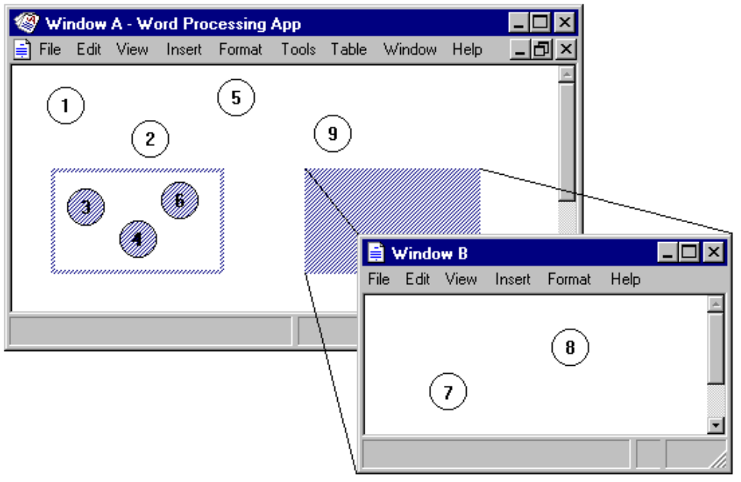

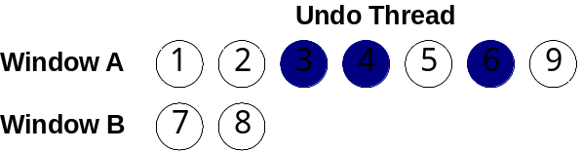

Figure 11.33 Undo Stacks of In-place and Open Objects.
The sequence of undo states pictured in Figure 11.33 is not necessarily meant to imply n-level undo. It is merely a timeline of actions which can be undone at 0, 1, or more levels, depending on what the container-object cooperation supports.

The active object actions and native data actions within Window A have been serialized into the same stack, while the actions in Window B have accumulated onto its own separate stack.

The actions discussed so far apply to a single window, not to actions that span multiple windows, such as OLE drag-and-drop. The ideal design when a single action spans multiple windows allows the user to undo the action from the last window involved. This is because in most cases, the user focuses on that window when the mistake is recognized. So if the user drags and drops an item from Window A into Window B, the action appends to Window B’s undo thread, and undoing it undoes the entire OLE drag-and-drop operation. Unfortunately, there is no system support for multiple window undo coordination. As a result, for multiple window actions, create independent undo actions in each window that participates in the action.

Messages
This section includes recommendations about other messages to display for OLE interaction.

Message Boxes
Use the following message boxes in addition to those described earlier in this chapter. Each message box description includes information about how and when to use it.

Object's Application Cannot Run Standalone
If the user attempts to open or run an OLE object's application that cannot run as a standalone application, display the message box in Figure 11.34.

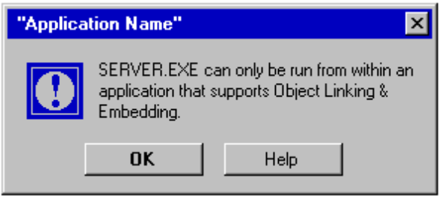

Figure 11.34 Warning Message When an Object's Application Cannot Run Standalone.

Cannot Locate Object's Application
When the user selects an entry from the Insert Object dialog box or activates an object, and the container cannot locate the requested object's application, display the message in Figure 11.35.

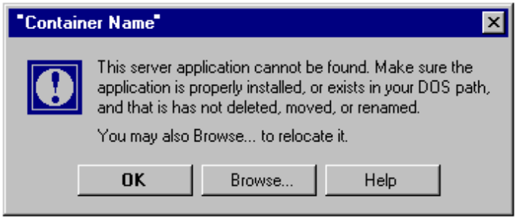

Figure 11.35 Warning Message When Object's Application Cannot Be Found.
The Browse button displays the common Open dialog box; the user-supplied path should be entered in the registry as the new object application path and filename.

If inside-out activation is supported for an object, display this message when the user tries to interact with that object, not when its container is opened. This avoids the display of the message to the user who only intends to view the content.

Object's Application Is Unavailable
An object's application can be unavailable for several reasons. For example, it can be busy printing, waiting for user input to a modal message box, or the application has stopped responding to the system. If the object's application is not available, display the message box in Figure 11.36.

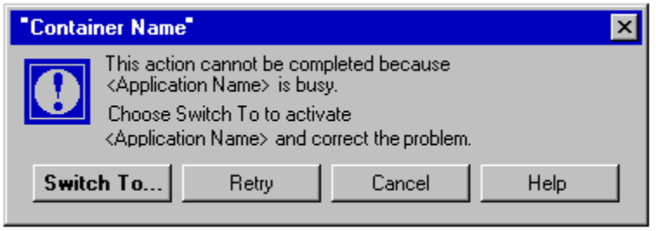

Figure 11.36 Object's Application Busy Warning Message.

Object's Type Is Not Registered
If the user attempts to activate an object whose type is not registered in the system registry, then display the message box in Figure 11.37.

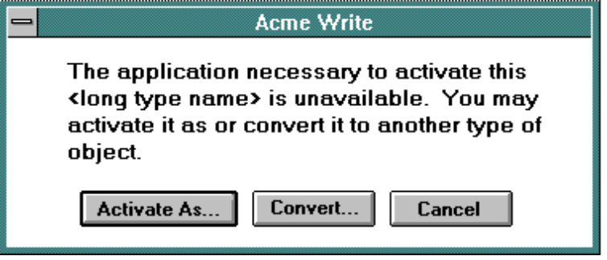

Figure 11.37 Object Type Not Registered Message.
Choosing the Convert button displays the Convert dialog box. Choosing the Activate As button displays a dialog box with a list of current types the user can use to edit the object. Ideally, an application that registers for type should be able to read and write that format without any loss of information. If it cannot preserve the information of the original type, then the application handling the type emulation displays a message box warning the user about what information it cannot preserve and optionally allows the user to convert the object's type.

For more information about the Convert button, see the section "Type Conversion" earlier in this chapter.

Link Update Message
While links are updating, display the progress indicator message box shown in Figure 11.38. The Stop button interrupts the update process and prevents any updating of additional links.

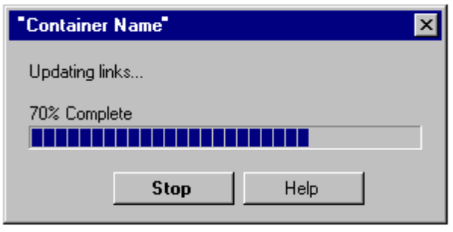

Figure 11.38 Progress Indicator for Link Updating

Linked Source Files Unavailable
If the source files for some links are unavailable, display the message box shown in Figure 11.39.

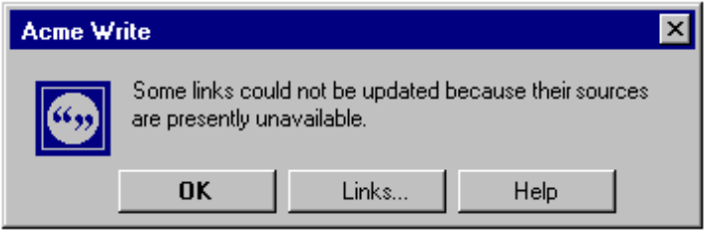

Figure 11.39 Warning Message for Unavailable Link Source.
This dialog box contains two buttons, OK and Links. The OK button closes the dialog box without updating the links. The Links button displays the Links dialog box, potentially allowing the user to change the link source.

Similarly, if the user issues a command to a link with an unavailable source, display the warning message in Figure 11.40. The unavailable link is marked as unavailable in the update status column of the Links dialog box.

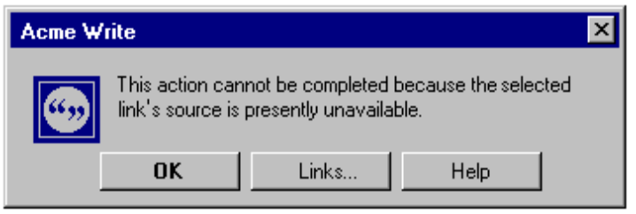

Figure 11.40 Warning Message for Issuing a Command to an Unavailable Link.

Operation Not Available Because Link's Source Type Changed
If a link's source type has changed, and the user chooses a command that does not support the new type, then display the message box in Figure 11.41.

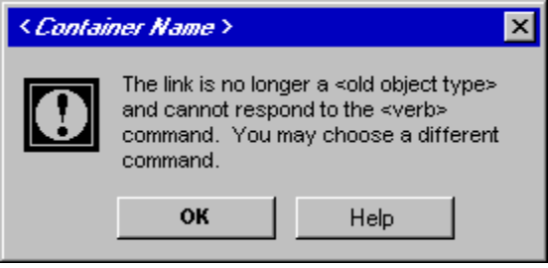

Figure 11.41 Message for Obsolete Operation for a Linked Object.

Status Line Messages
Table 11.3 lists suggested status line messages for commands on the primary container menu of an opened object.
Table 11. 3 File Menu Status Line Messages
Command | Status line message
Update <container-document> | Updates the appearance of this <full type name> in <container-document>.
Close & Return to <container-document> | Closes <object name > and returns to <container-document>.
Save Copy As | Saves a copy of <descriptive type name> in a separate file.
Exit & Return to <container-document> | Exits <object application > and returns to <container-document>.

Note If the open object is within an MDI application with other open documents, the Exit & Return to command should simply be "Exit". There is no guarantee of a successful Return to <container-document> after exiting, because the container might be one of the other documents in that MDI instance.

Table 11.4 lists the recommended status line messages for the Edit menu of containers of embedded and linked objects.

Table 11. 4 Edit Menu Status Line Messages
Command | Status line message
Paste <object name*> | Inserts the content of the Clipboard as <object name>.
Paste Special | Inserts the content of the Clipboard with format options.
Paste Link [to] <object name*> | None.
Insert Object | Inserts a new object.
<command> [Linked] <object name*>  (If no command in the registration database is specified, use "Activate".) | None.
[Linked] <object name*> [Object] | Apply the following commands to <object name>.
[Linked] <object name*> [Object] <command> | None.
[Linked] <object name*> [Object] Properties | Allows properties of <object name> to be viewed or modified.
Links | Allows links to be viewed, updated, opened, or removed.
*<object name> may either be the object's short type name or its filename.

The following table lists other related status messages.

Table 11. 5 Other Status Line Messages
Command | Status line message
Show Objects | Displays the borders around objects (toggle).
When an object is selected | Double-click or press enter to <default -command> <object name or full type name>.

Note The default command that is stored in the registry will contain an ampersand character (&), the access key indicator, that must be stripped out before the verb is displayed on the status line.

